In this step, get ready to:
Open Amazon S3. Create a storage space for your website files.
- Log in to the AWS console.
- In the AWS Management Console, search for S3.
- 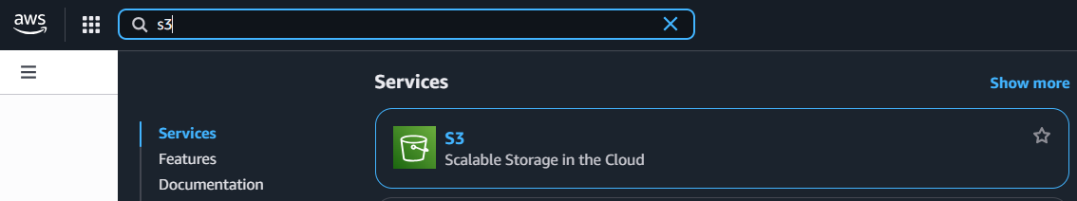
- Select the AWS Region closest to you. You can find this at the top right corner of your AWS Management console, right next to your name.
- Choose Create bucket. 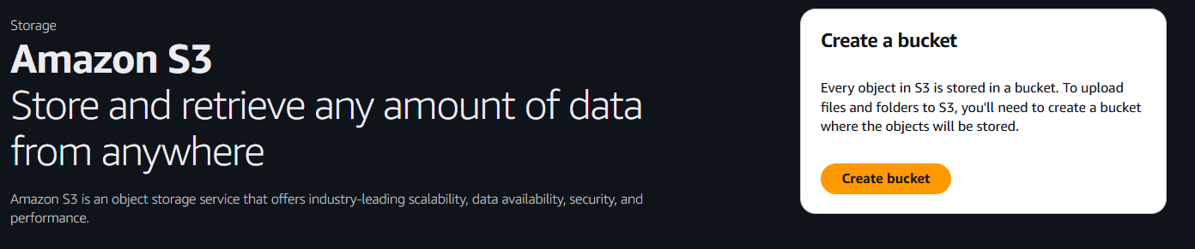
- For Bucket name, enter project1-thegourmetgrille
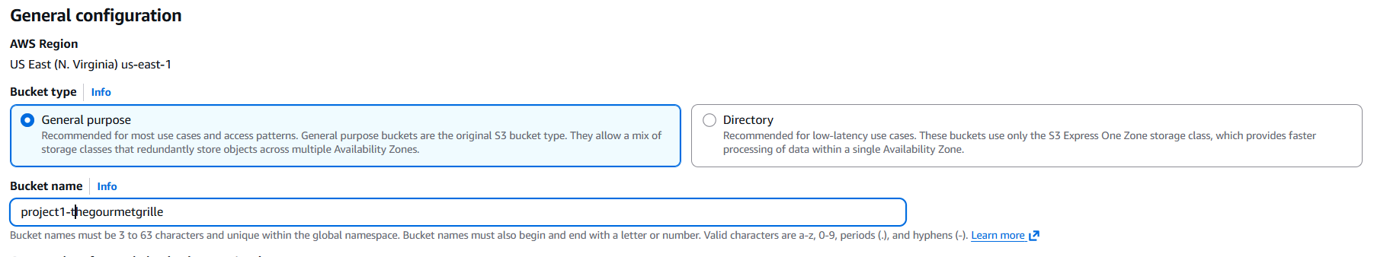
💡 Why do I have to enter in the bucket name?
An S3 bucket name is globally unique. After you create a bucket, no other AWS account in the entire world can use your bucket's name (unless you delete the bucket).
This also means that when you create your bucket, you need to make sure the bucket's name is unique too.
- For Object Ownership, choose ACLs enabled.
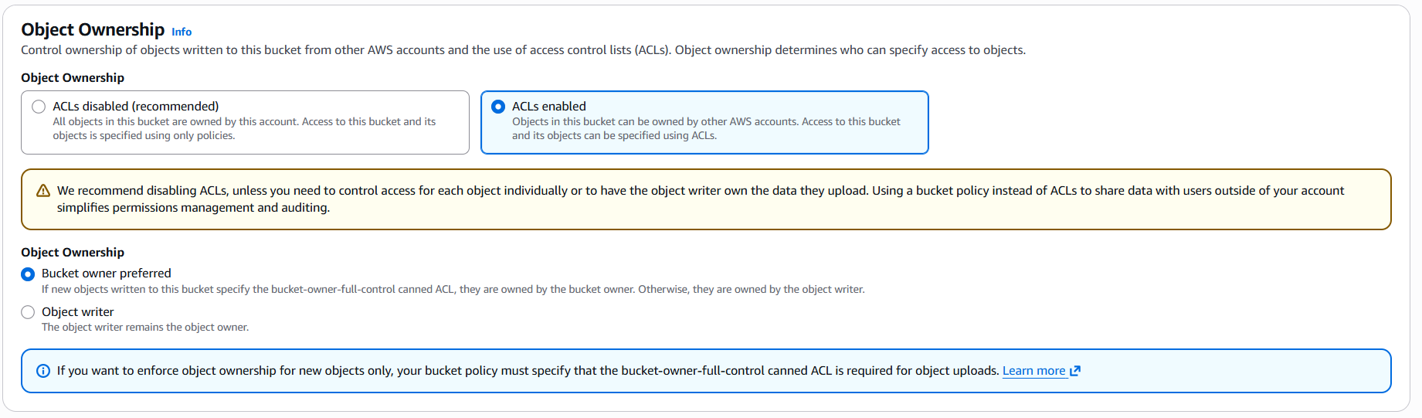
💡 Ooo what are ACLs (Access Control Lists)?
An ACL = a set of rules that decides who can get access to a resource.
Enabling ACLs in this S3 setup lets you control who can access and do things with the objects (i.e. website files) you upload into your bucket.
With ACLs, different AWS accounts can own and control different files in your bucket.
💡 What is the yellow pop up saying?
A yellow warning banner will pop up when you enable ACLs. This banner tells you that it's simpler to use another tool called bucket policies.
It's true that bucket policies make it really easy to control access for an entire bucket (e.g. making the entire bucket and everything inside public), but ACLs are the way to go if you want to manage access for each object in your bucket individually.
In this project, we're using ACLs to show you how they work.
- Choose Bucket owner preferred.
- For Block Public Access settings for this bucket, clear the check box for Block all public access.
💡 A yellow banner has popped up!
This banner is telling us that the bucket and its objects might become public if we untick the checkbox. This is what we want to host a public website!
- Check the box that says “I acknowledge that the current settings might result in this bucket and the objects within becoming public.”
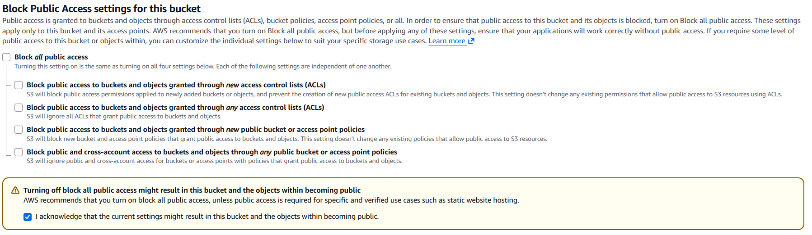

- For Bucket Versioning, choose Enable.
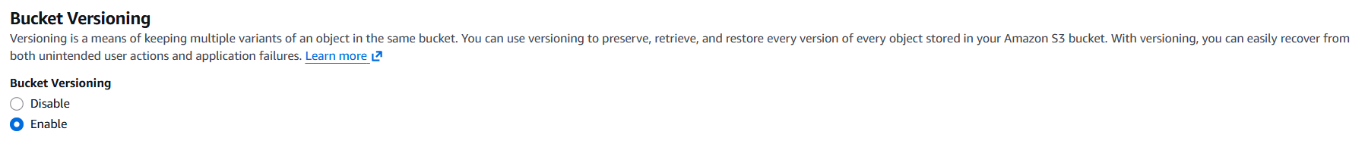
- Choose Create bucket.
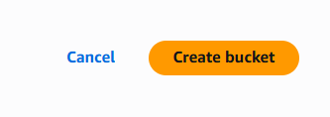
That's your S3 bucket all created.
Time to get those website's files inside your bucket! 📑 ➡ 🪣

In this step, get ready to:
Download an HTML file that sets up your website.Download a zip file of images for your website.Upload both files into your S3 bucket.
- In the Buckets section, choose the name of your new bucket.
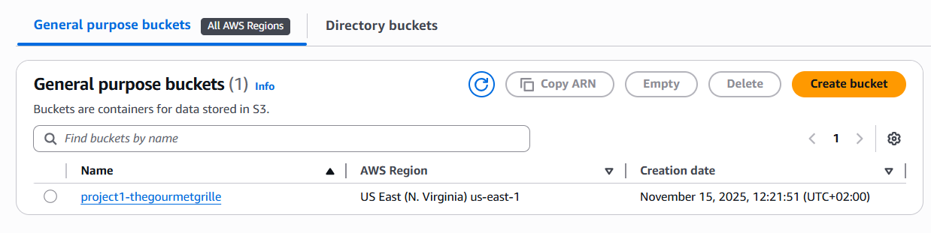
Open the folder with the app details in your local computer.
💡 Return to the Amazon S3 console with your bucket page open. Choose the Objects tab.
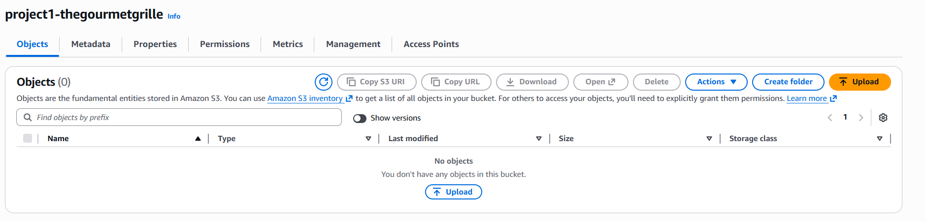
- Choose Upload.
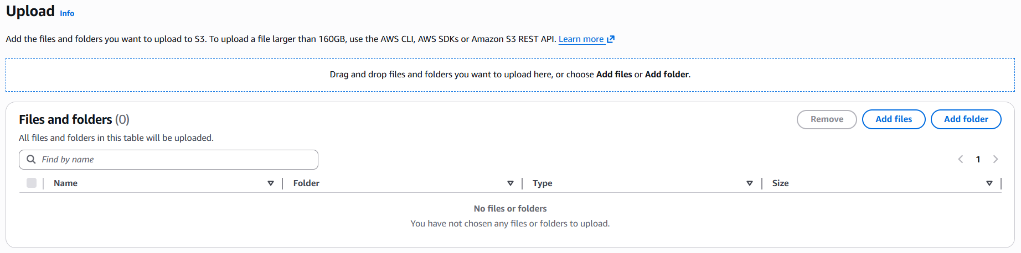
- Choose Add files.
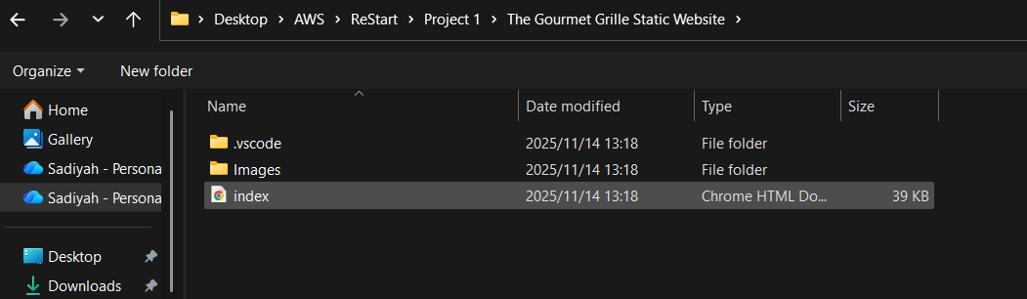
- Choose index.html.
- Choose Add folder.
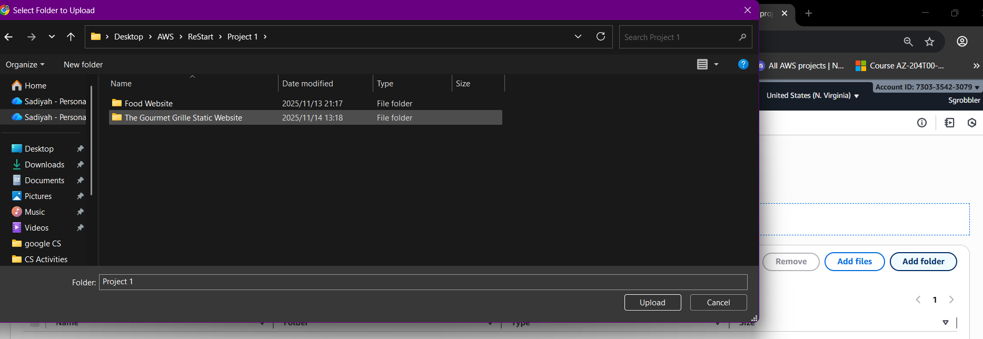
- Choose the folder
- You might get a popup that tells you that all files in that folder will be uploaded ("Do you want to upload 44 files?"). Select Upload if you need to!
- Choose Upload in your AWS console.
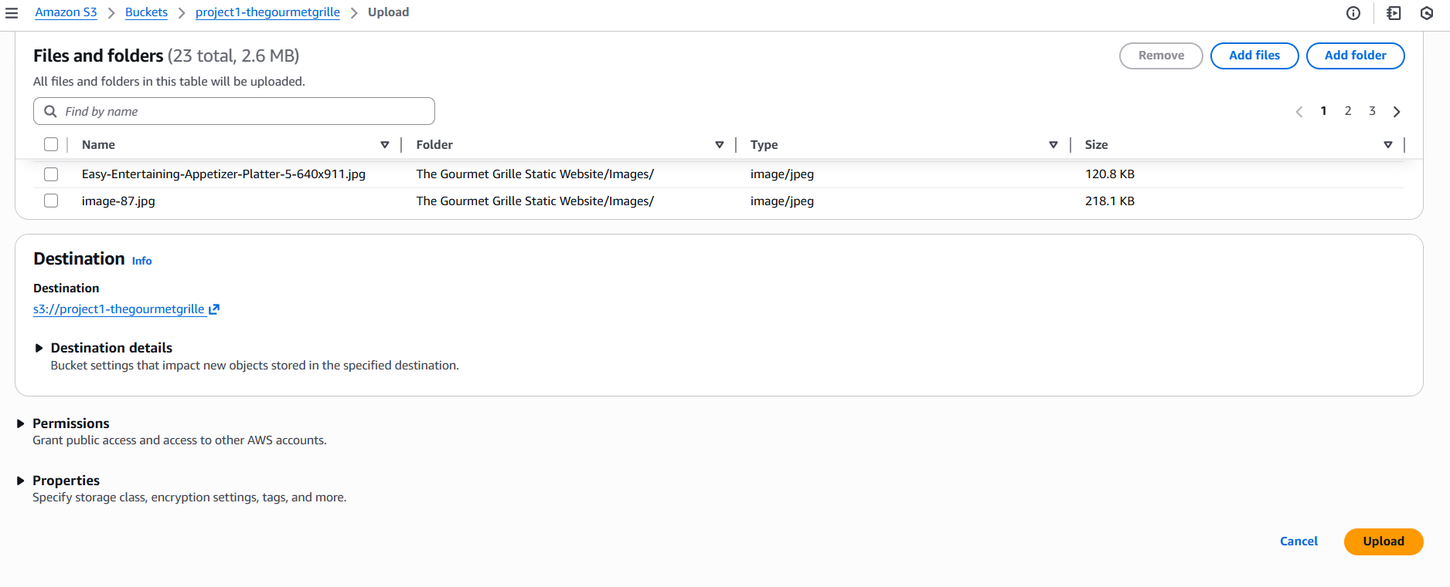
- S3 will get to work right away!
- While we wait for your files to upload...
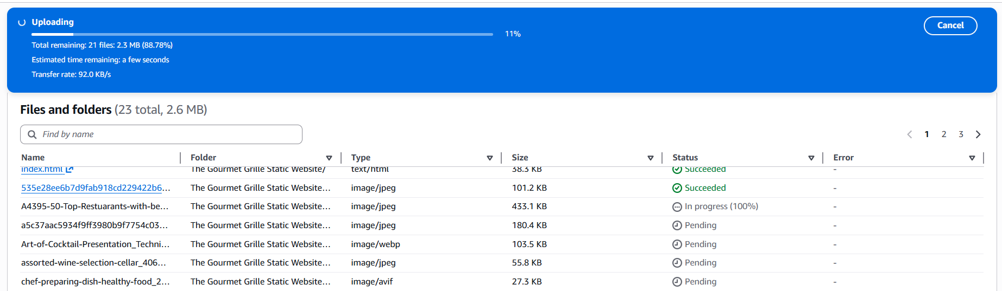
- Choose Close underneath the green Upload succeeded banner.
Great succcess.
S3 bucket? Created ✅
Website files? Uploaded ✅

Next up, let's make your website available on the internet by setting up static website hosting!

In this step, get ready to:
Configure your S3 bucket for static website hosting Visit your public website link.
💡 What does website hosting mean?
Website hosting is what makes your website public on the internet.
Even if you perfect an HTML file, no one else can see it when it's stored as a local file on your computer! Website hosting = storing your HTML file (and the other files for your website) on a web server, so it's accessible online.
By configuring your S3 bucket for hosting, we're telling this bucket: "please create a URL that will take anyone to a page that displays the HTML file I just uploaded."
- Make sure you're back in your bucket's page. If you're not sure, choose General purpose bucckets on the left hand side navigation bar, and then choose the bucket you created for this project.
- Choose the Properties tab.
- 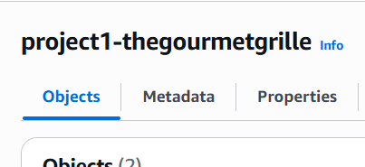
- Scroll allllllllll the way down to the Static website hosting panel.
- Choose Edit.
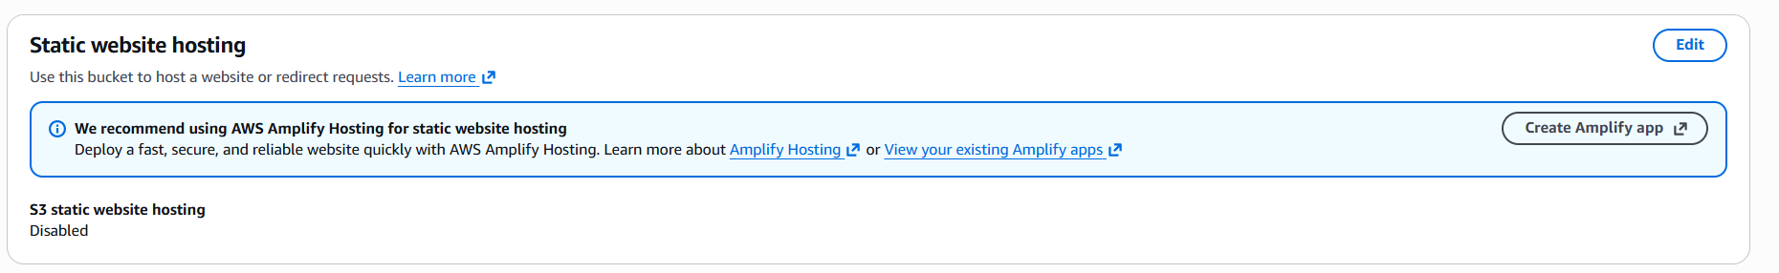
- Configure the following settings:
  - Static web hosting: Choose Enable.
  - Hosting type: Choose Host a static website.
  - Index document: Enter index.html
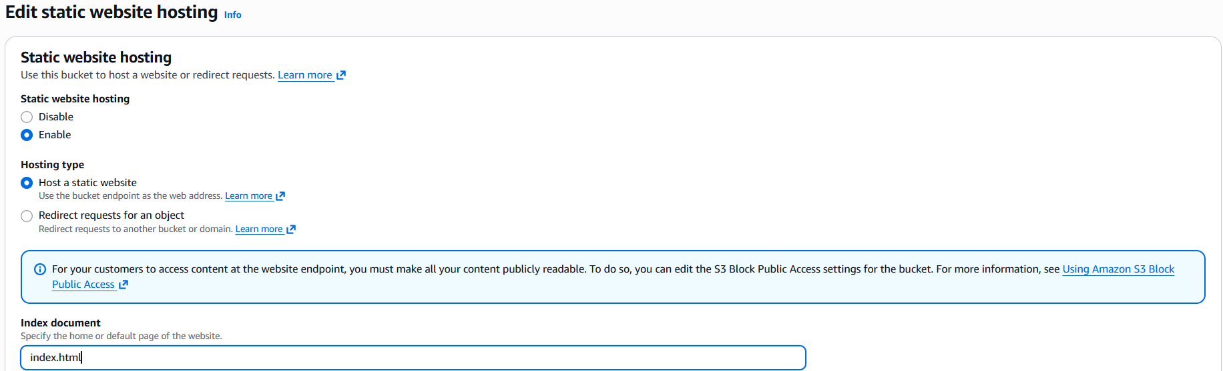
- Choose Save changes.
- In the Static website hosting panel, click on the URL under Bucket website endpoint.
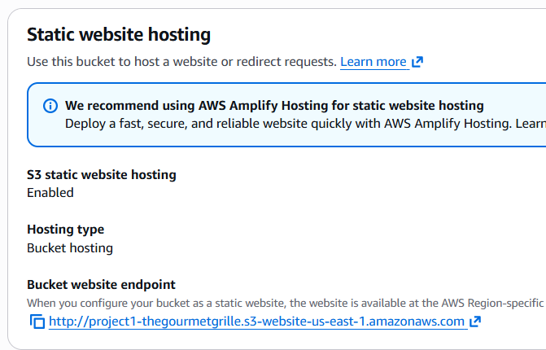
💡 What's a bucket website endpoint?
A bucket website endpoint is just like a regular website URL. It lets people visit your S3 bucket's files as a website.
An error! 👀
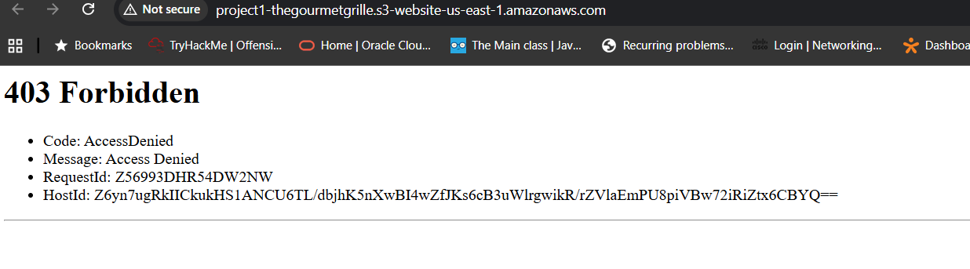
💡 Why did I get this error?
Objects (in this case, the HTML and images files you uploaded) are private by default. This default setting helps keep your account's data secure.
The error message you're seeing is telling you that your static website is being hosted by S3, but the actual HTML/image files you've uploaded are still private. It's kind of like having a bucket on display, so everyone can see the bucket - but the contents are covered up, preventing anyone from seeing what's inside.
To solve this error, we need to set the permission of the objects to public - this is why we enabled ACLs in Task 1!
The only missing ingredient is to make your website files publicly accessible, so everyone has permission to view your website.

Make your website files in S3 publicly accessible.See your website live on the internet!
- Select the Objects tab.
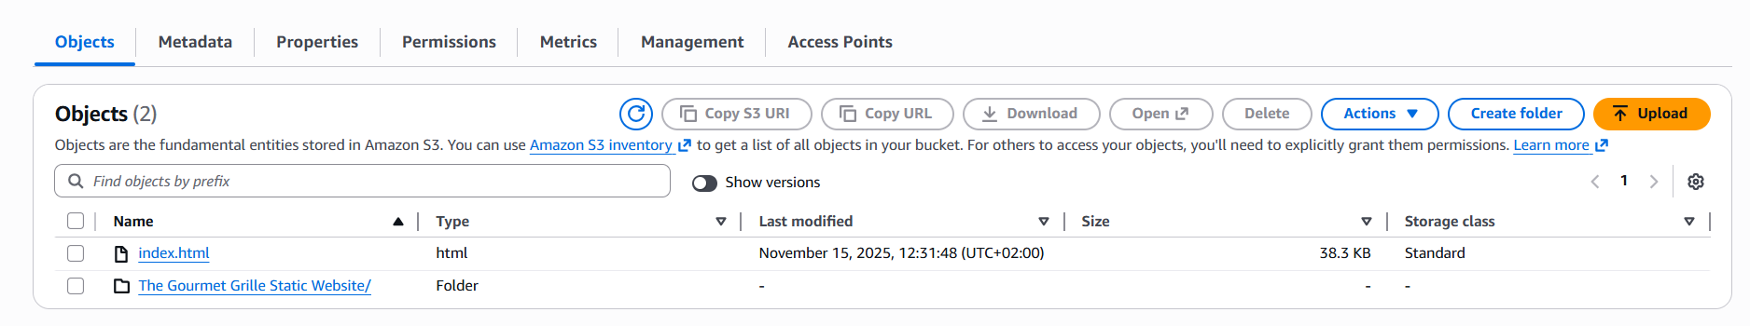
- Select the checkboxes next to your index.html file and the folder of website assets.
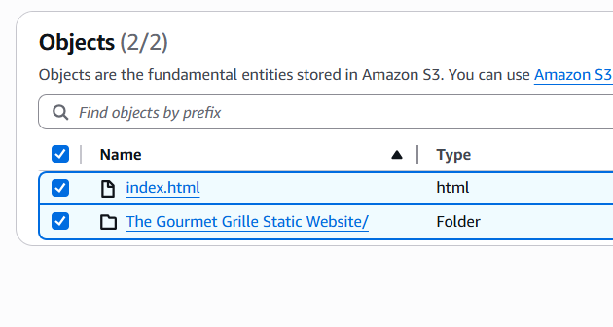
- In the Actions dropdown, choose Make public using ACL. Choose Make public.
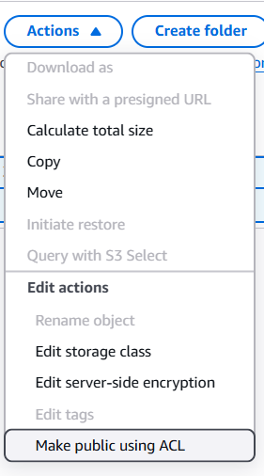
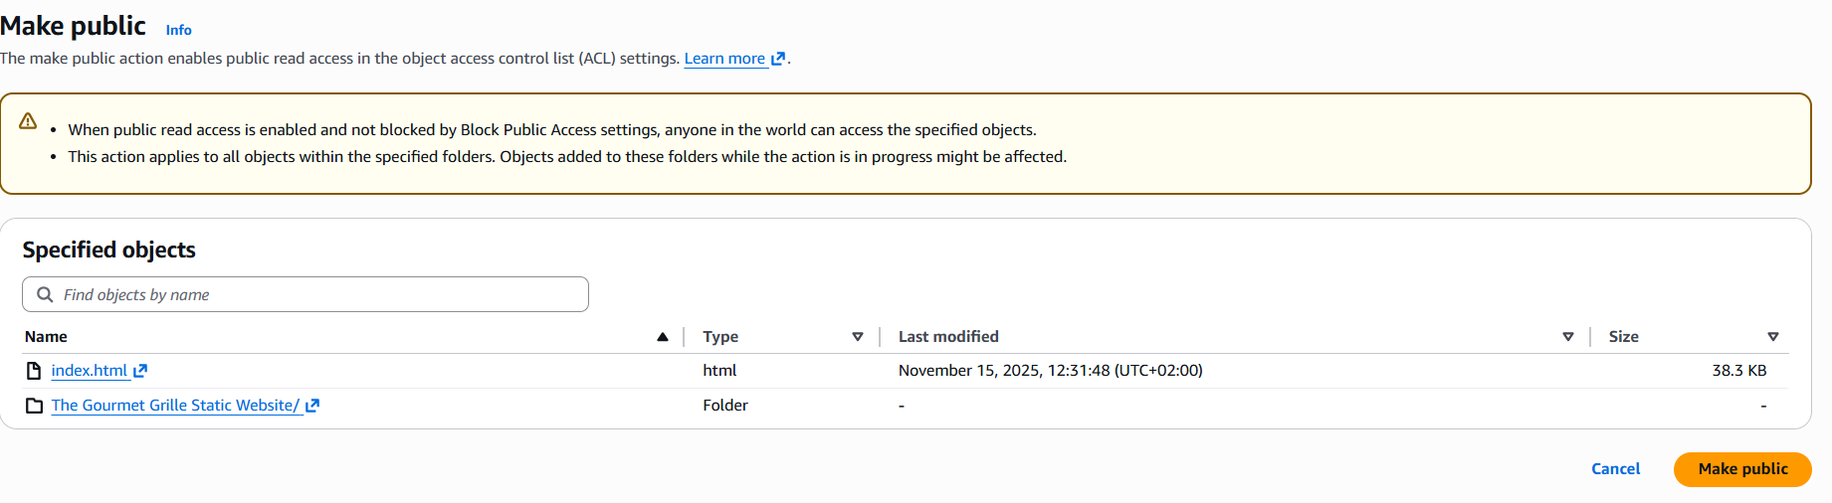
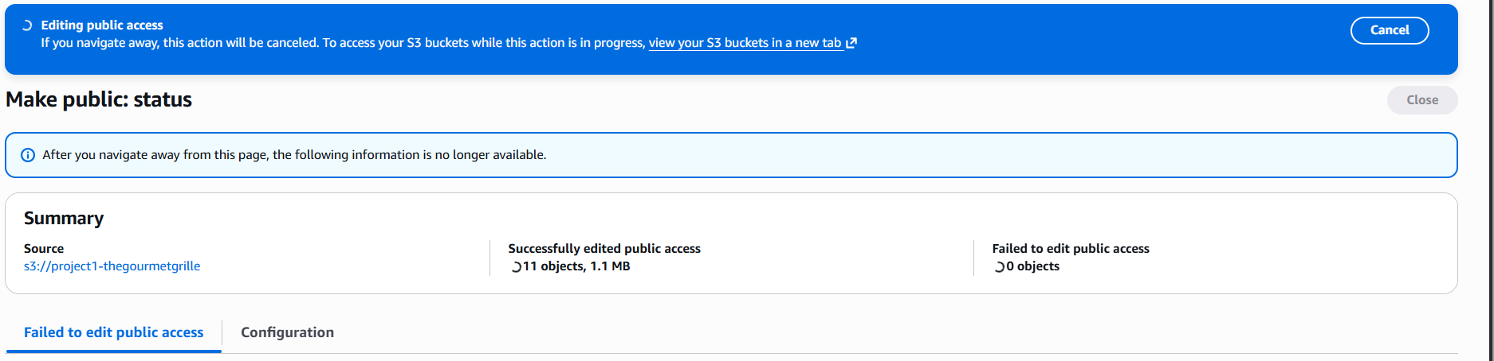
- Once the green banner pops up, choose Close.
- Return to the web browser tab that has the 403 Forbidden message.
- Refresh the tab.


DONE

